**QSMART – CPU BOARD REPLACEMENT**

**PROCEDURE**

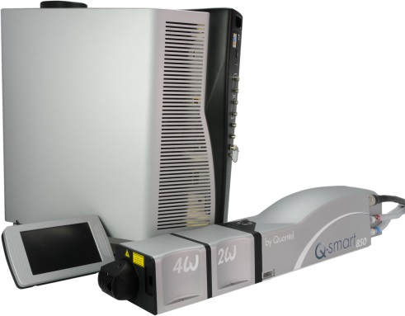

**Toolkit:**

Allen keys

**System** : QSMART

|  |  |  |  |  |  |  |  |  |  |  |
| --- | --- | --- | --- | --- | --- | --- | --- | --- | --- | --- |
| |  |  | | --- | --- | | 4/300/1077 | **Q-SMART KEY CCA** | | | | | |  |  |  |  |
|  |  |  |  |
|  |  |  |  |

**Purpose:** This document details how to change the CPU board

|  |  |  |
| --- | --- | --- |
| Revision | date | modification |
| Initial issue | July 4, 2014 |  |
|  |  |  |
|  |  |  |
|  |  |  |

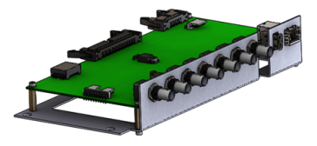

# DISASSEMBLY

* Unplug the system and disconnect all cables

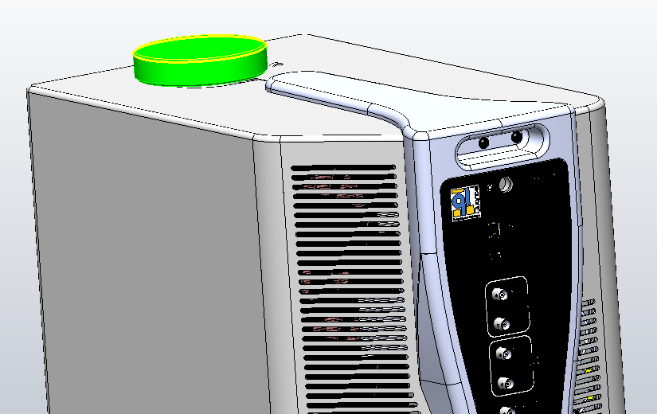

* Remove the CG cap

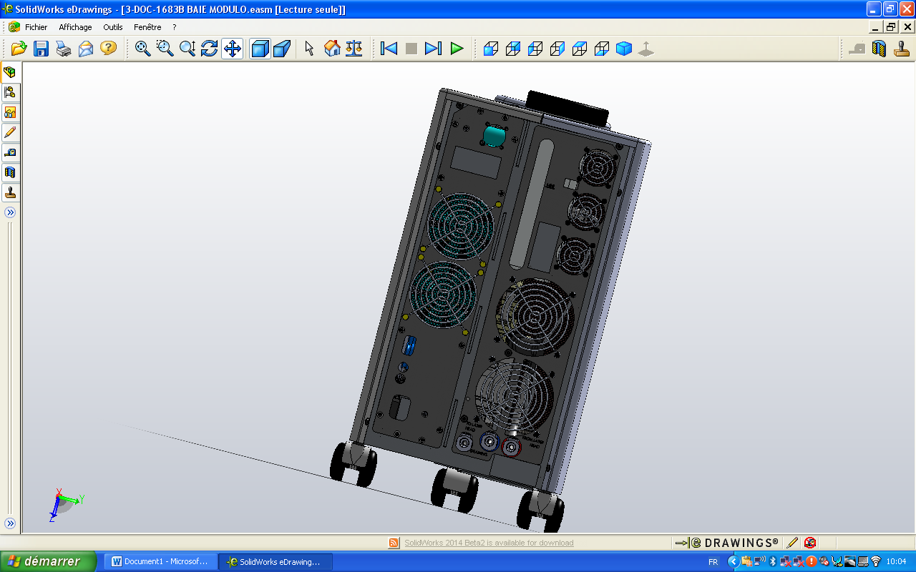

3/E13/0600

* Remove the 4 screws 3/E13/0600 (Rear panel)

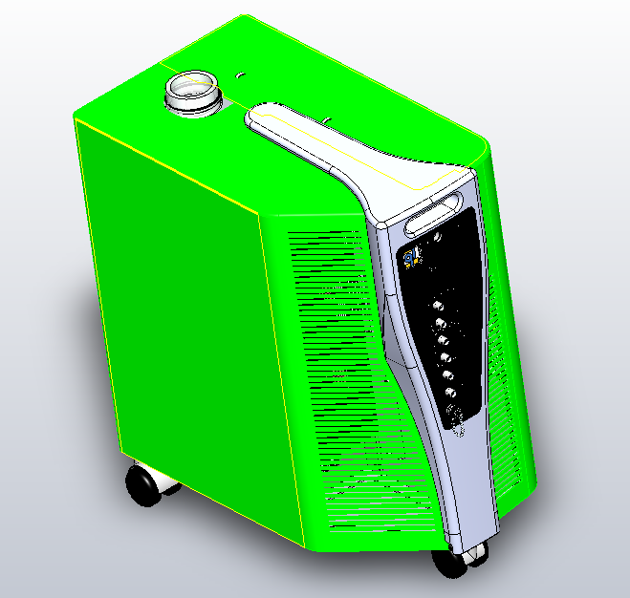

3/E13/0600

Enlever les 4 Vis 3/E13/0600 (face avant). Enlever les deux flasques 3/PNT/0511 et 3/PNT/0512

* Remove the 4 screws 3/E13/0600 (front). Remove the two side panel

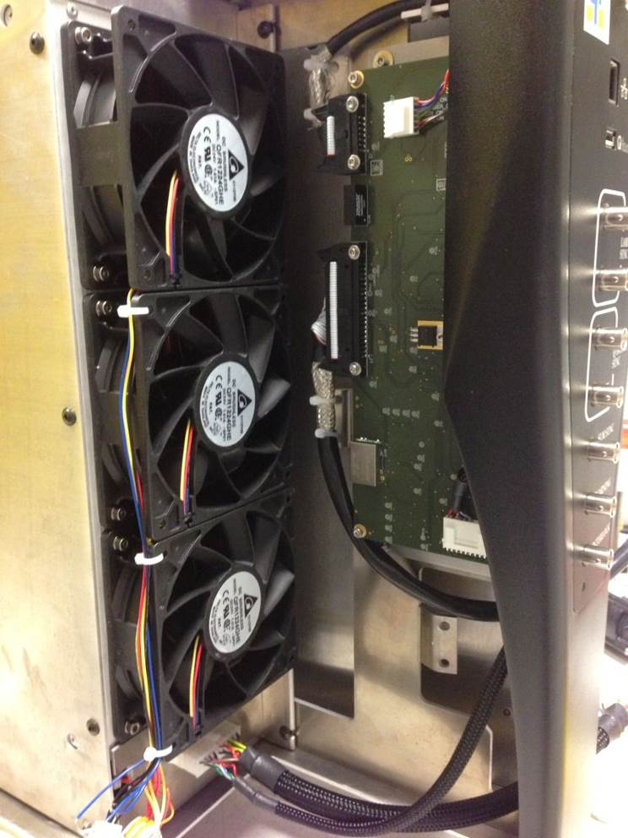

Disconnect the cable kit 4/300/1070 from the CPU card. Remove Tyraps.

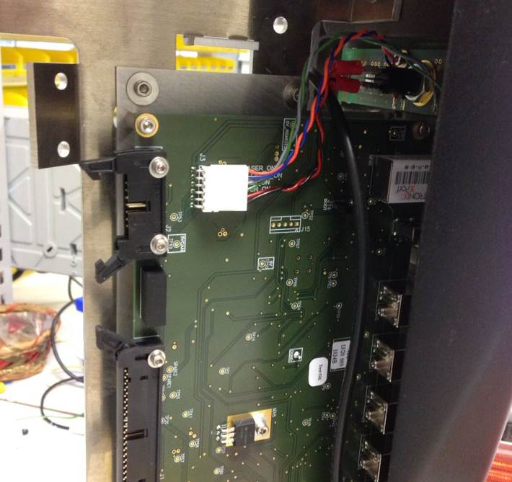

* Disconnect the key card from the CPU as pictured.

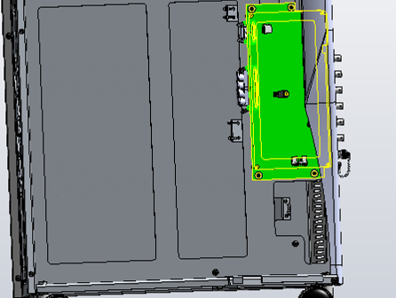

Remove all BNC connections in the front

Disconnect the BNC security.

Remove the CPU card by unscrewing the 4 screws CHC 3x8 + 4 washers LU3.

# Integration of the CPU Board

|  |  |  |
| --- | --- | --- |
| 4.00 | V/CHC-M0308-A4 | CHC 3x8 SCREW |
| 4.00 | R/LU--D03--A2 | LU3 WASHER |



Fasten the CPU card using 4 screws CHC 3x8 + 4 washers LU3.

Check the BNC connections, it should connect well without straining.



Connect the key card to the CPU as pictured.



Tyraps

Connect the cable kit 4/300/1070 to the CPU card and attach each cable to the frame with tyraps as shown on the picture.

Connecter le kit câble 4/300/1070 à la carte CPU et au groupe de froid et attacher chaque câble au bâti avec des tyraps comme sur photo ci-contre.

# COVERING

|  |  |  |
| --- | --- | --- |
| 8.00 | 3/E13/0600 | BLACK BHC 4x12 SCREW |

Implement both side panels and fasten with 8 BHC Black 4x12 (3/E13/0600) screws



3/E13/0600



3/E13/0600

CAUTION: Leave a space between two covers

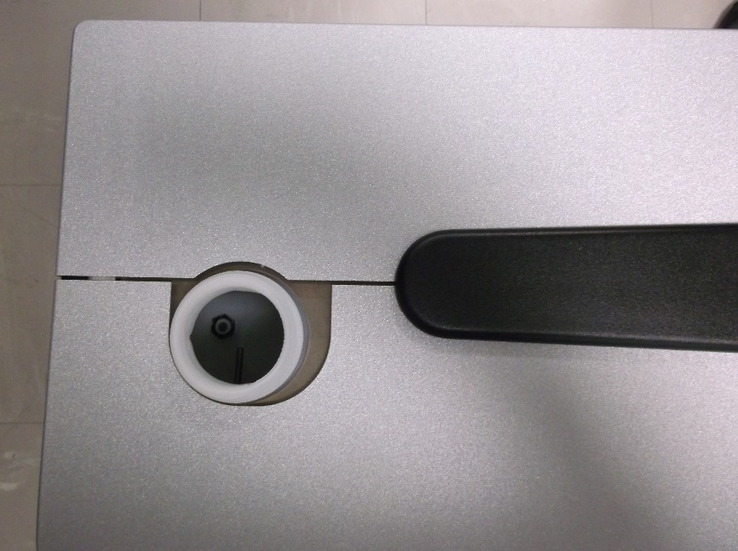



Reinstall the CG cap